Calculate how much amount of integers can be stored in i16, u16, i32

and u32.

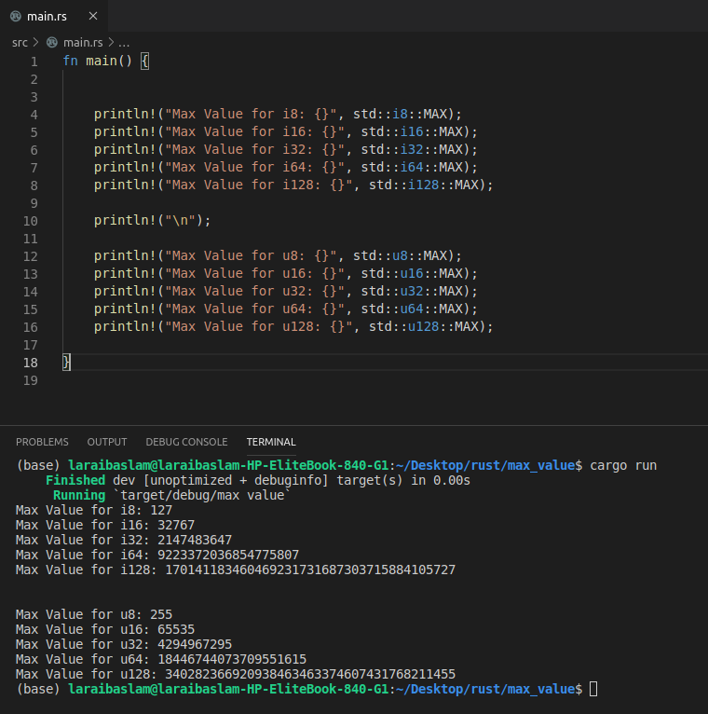

Complete read chapter no.2 of the rust programming book and make the program for guessing game which is being instructed in this chapter.

